Doughnut Economics: The Sweet Solution to a Growing Problem
“Economics is the mother tongue of public policy, the language of public life, and the mindset that shapes society.” – Kate Raworth, Doughnut Economics: seven ways to think like a 21st century economist, 2017
It is no exaggeration to say that human society in the modern world is one of the most complex, demanding, and often times unforgiving systems that we have created. As it is ever evolving and progressing, its needs are constantly changing. New problems require new solutions.
The long-term, widely accepted understanding of economic success has been through the measurement of a country’s GDP per capita, or the sum of its economical output divided by its population. But as populations continue growing, and the distribution of wealth continues to be more and more uneven, this statistic is often times vastly unrepresentative of the actual economic state of a land. Doughnut economics is not based on “long established theories, but with humanity’s long-term goals” instead. The goal is not to increase a country’s GDP or economic output infinitely, but rather to meet the human rights of every person while minimizing impact on the natural world, or how Kate phrases it: “within the means of our life-giving planet”.
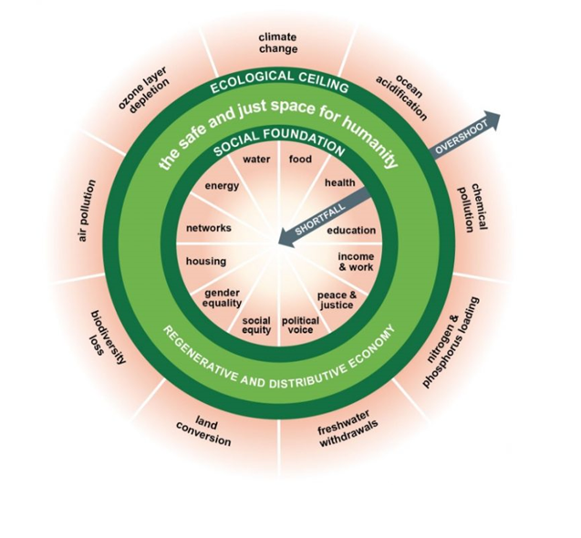
Kate Raworth designed the doughnut economic model with two rings, or boundaries, that encapsulate the needs that a regenerative and distributive economy meets, and the problems that it avoids. Falling into the center doughnut would spell a shortfall, when that specific need is not meet throughout the entire society, such as a food shortage, homeless population, social inequity, etc. Likewise, when the economy begins to overproduce, or stray from a sustainable practice, it will represent an overshoot such as biodiversity loss, freshwater crisis, chemical pollution, etc.
It is human nature to be dependent on the natural world, and it goes without saying that we cannot exist without it. The current system of pursuing a larger economic output, often times at the expense of the limits of what the natural world can produce, has already begun to spell disaster as the world’s population increases and energy and resource needs rise exponentially. But with efficiency and longevity at the forefront of economic decision-making instead of pure quantity and monetary value, society would be able to exist within the natural world as it always has without risking the complete exhaustion of many resources considered essential to the means of production.
Some of the most prevalent aspects of life have evolved in such ways to accommodate the modern era, including medicine, education, infrastructure, etc. But the teaching and general concept of economics up to modern day has remained rooted in the fundamental theories that have shaped it since the 19th century. What would our world look like today if we were limited to the medical sciences and understanding of the 1850’s, when a patient’s best chance of recovery from an infection on the foot was to amputate, or when being treated for one disease could result in the body’s inoculation of an entirely new one due to the immense lack of sterility and aseptic practice?
Society’s need for a new economic system is here, and pure monetary value will no longer sufficiently account for everyone in this growing world. Doughnut economics provides a better model for accounting for everyone and their needs within in a society. Infinite growth has never been achievable in nature, rather her processes all work through cycles. It’s time to start thinking circular!

https://www.cfse.cam.ac.uk/parallel_forum/article_shadrach_kerwillian_march_2015
https://doughnuteconomics.org/about-doughnut-economics
Doughnut economics: how to bake a better future - META (eeb.org)

